Basics Of Sightly- Assignment

**1.) Print current time.**

**2.) Create a list of resources under /content/my-options and add two properties "text" and "value" on each resource. Create a dropdown (HTMl select) using the resources list as options.**

**3.) Read the color property from the current node and set it as the backgorund of the page.**

**4.) Add the dropdown created in Q-2 under two different containers (div tag) with different background colors.**

1) **logic.js**

use(function () {

return {

message3:java.util.Date().toString()

};

});

**Page.html**

<h2>Current date and time is</h2>

<p> ${obj.message3}</p>

2) create a dropdown in html and instead of hard coded values pass

${resource.listChildren }

to get the list of child resources.And to obtain their value:

<option value="${item.valueMap.value}">${item.valueMap.text}</option>

3)<style>

body{

background-color:${properties.backgroundcolor};

}

<style>

4) <div class="done">

Background Color: Pink

<select data-sly-list="${resource.listChildren }">

<option value="${item.valueMap.value}">${item.valueMap.text}</option>

</select>

</div>

<div class="dtwo">

Background Color: Aqua

<select data-sly-list="${resource.listChildren }">

<option value="${item.valueMap.value}">${item.valueMap.text}</option>

</select>

</div>

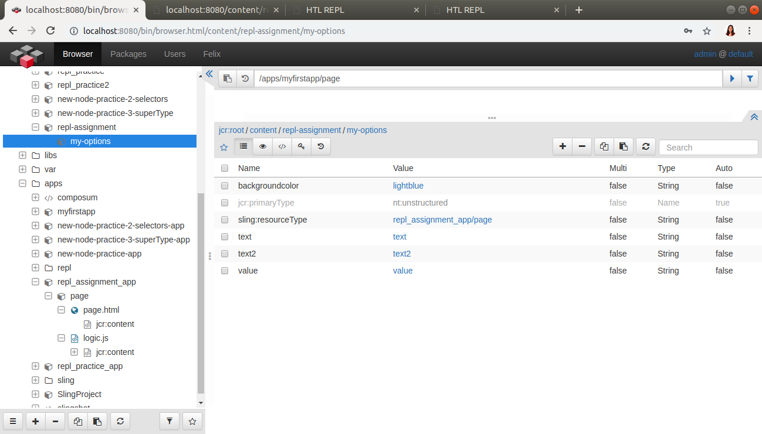

**Page.html**

<!DOCTYPE html>

<html>

<head>

<style>

.div{

height:500px;

text-align:center;

}

.done{

background-color:pink;

}

.dtwo{

background-color:aqua;

}

</style>

</head>

<body data-sly-use.obj="${'logic.js'}" , bgcolor='${properties.backgroundcolor}'>

<h2>Hoverable Dropdown</h2>

<div class="done">

Background Color: Pink

<select data-sly-list="${resource.listChildren }">

<option value="${item.valueMap.value}">${item.valueMap.text}</option>

</select>

</div>

<div class="dtwo">

Background Color: Aqua

<select data-sly-list="${resource.listChildren }">

<option value="${item.valueMap.value}">${item.valueMap.text}</option>

</select>

</div>

<h2>Current date and time is</h2>

<p> ${obj.message3}</p>

</body>

</html>